DATA ANALYSIS PROJECT - AWS CLOUD CLUB, FUTA
December 2025, AWS Cloud Club started in Akure, in the heart of FUTA, of course. These past weeks have been filled with onboarding the members, community engagement and of course, the first community webinar.
The community webinar is slated to hold today, Monday 22nd December 2025 and we have high hopes of a huge turn out from members and techies in Akure and beyond.
In the meantime, I decided to work on the data collected in the Google form that gave people access to the community. According to the form, we received 165 responses which two of them were from the Cloud Captain (Asolo Delightsome) and I, the Program Lead when we were testing the link after publishing it.
So, here’s the raw data:
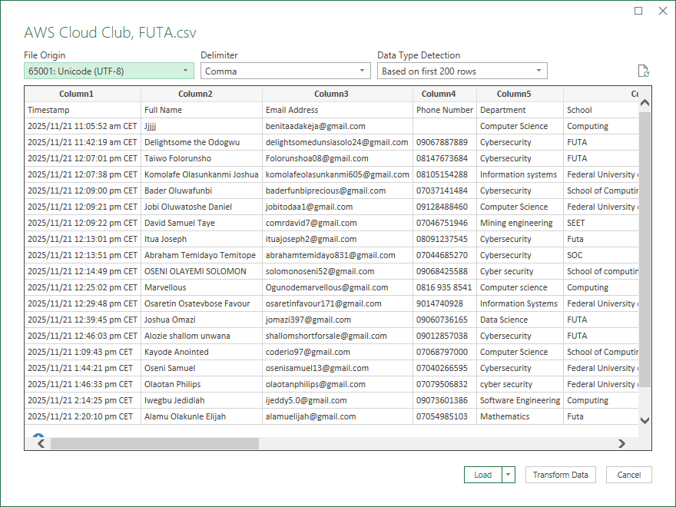
We have several fields like:
- Timestamp, which of course is date and time,
- Full Name, evidently of string data type,
- Email address, which can be a mix of strings and whole numbers and special characters
- Phone number
- Department
- School, which is to indicate their faculty, but seeing we have non-FUTArians, it can also indicate their institution
- Level (100l – Postgraduate)
- Current Cloud knowledge (Beginner to Advanced)
- Then questions like: Are you preparing for or taking any cloud certifications, why do you want to join AWS Cloud Club?
- Finally, what cloud areas interest you the most?
So, I’ll start with cleaning the data of course, I realized the time stamp is in CET and CET in December according to research is same as WAT. I should probably separate Date from Time, too. So, I did that and now, we have Date and Time as separate columns:
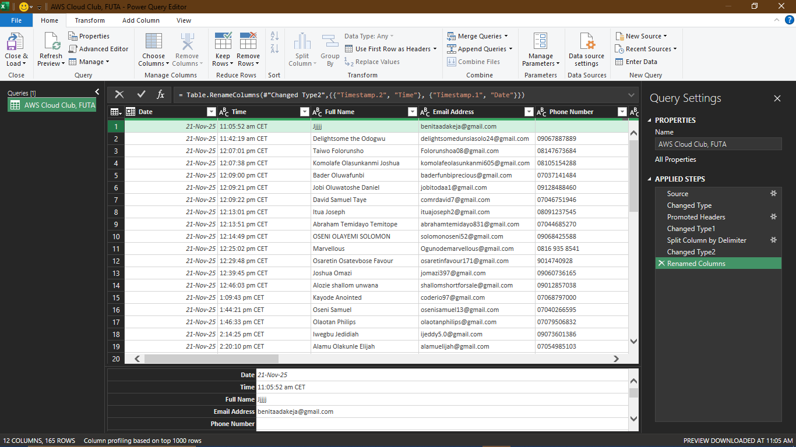
So, after this, I loaded my data to excel, then the standardization began.
I started by removing duplicates, of which there was just one. Then, for the School, I replaced everyone by either their faculty and I left the rest for students who were not FUTArians, currently, there are only three (University of Port Harcourt, Achievers University Owo and Bowen University).
I also standardized the various departments, e.g. cyber security to Cybersecurity amongst may others. I changed a column name from “What Cloud areas interest you the most? “to ‘Cloud Interest’ then I created a column for motivation category, right after the “Why do you want to join “column to sort the reasons under these:
- None
- Learning / Skill growth
- Career opportunities
- Community/Networking
- Certification/AWS Exposure
- Curiosity/Exploration
- Other
Then, I used data validation under data to make it easy for me to remember. I put the motivation in a new sheet and used the data value as list for easy access.
So, I wanted to know the cloud interest, i.e., how many people are interested in this field, so, I loaded the file into power query and I split by delimiter into rows. One person can select multiple cloud interests, so the data is structured to reflect that. When I want to count the number of people, I’ll count unique emails. When I want to count the popularity of cloud paths, I’ll count interests.
On importing to power query, I imported three sheets; one that didn’t have the cloud interest column split, One that had the cloud interest column split into rows and one for data validation. I renamed the one that did not have the cloud interest column split as Respondents as it only has the most important details about the respondents and nothing else. I deleted the date and time columns and the “Why are you joining?” column. I kept only the basic rows and I ensured I removed duplicates.
I created another table to split the “Are you preparing for or taking any certifications?” column and I renamed it as certifications in all tables.
Later on, I realized a person used the same email address to sign in twice, but changed the placement of their names, so I had to remove duplicate values by removing duplicate rows. I’m glad I learned that.
I did a One-to-one relationship between the respondents and certifications table and the respondents and Cloud interests table, making it a One to many relationship between the Respondents table and the remaining two tables.
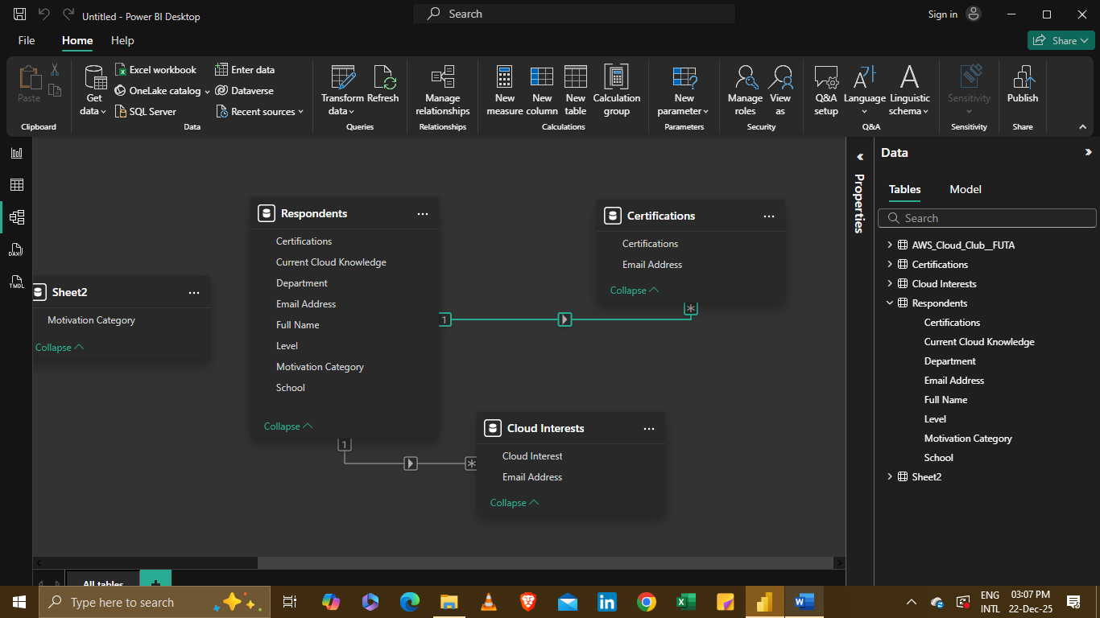
When I finished this, I realized it was time for measures, visuals and charts and the first measure I created was the Total Respondents measure which counted each respondent distinctly.

